Module 4: Functions and Goals of Financial Management 1
Lesson 1: Financial Functions 1
Learning Objectives 1
Overview of Financial Operations 2
Accounting and Financial Reporting 7
Budgets and Cost Accounting 19
Treasury Operations and the Investment Management Function 27
Securities in the Insurer's General and Separate Accounts 34
Audit and Internal Control 43

Module 4: Functions and Goals of Financial Management
Policyowners and beneficiaries depend on their insurer to meet its obligations when they come due. The insurer’s financial area has a large part of the responsibility of ensuring the company remains strong for its customers. In this module, we’ll discuss the variety of activities that take place in the financial management area and we’ll explore the financial management goals that are common to all insurers.
In this module, you’ll learn about
- The different aspects of an insurer’s financial operations, including accounting, financial reporting, treasury, investing, and auditing
- The goals of an insurer’s financial operations, including maintaining solvency, achieving profitability, and managing capital

Lesson 1: Financial Functions
---- - -- - --
As a financial services company, an insurer has to manage not only its own funds but also the funds of its customers. Learn about the various functions that help an insurer stay on a sound financial footing and that contribute to its profitability.

Learning Objectives

- Describe how an insurance company's chief executive officer (CEO) and senior financial management direct the company's financial operations.
- Describe the responsibilities of the accounting and financial reporting function.
- Identify internal and external users of accounting information, and describe how financial accounting and management accounting meet their different needs.
- Describe how insurers use budgets and cost accounting as control tools.
- Describe the treasury operations activities of cash management and liquidity management.
- Describe the investment management function, including the role of the investment committee and the purpose of the investment policy.
- Describe the different types of securities, and distinguish between debt securities and equity securities.
- Distinguish between an insurer's general account and separate account portfolios.
- Explain the importance of the audit and internal control function, and describe other players in an insurer's financial operations.

Overview of Financial Operations
Learning Objective
Describe how an insurance company's chief executive officer (CEO) and senior financial management direct the company's financial operations.

At a typical insurance company, which of the following areas are part of financial operations? Choose all that apply.
- Accounting and financial reporting
- Treasury operations
- Information technology
- Investment operations
- Internal audit
Forthright's financial operations unit not only tells the world about the company's success but it also plays a crucial role in ensuring that success. Financial operations assists management by doing things like providing financial reports, safeguarding and managing assets, and developing investment strategies for the company. This unit must respond to the demands of the company's board of directors, regulators, investors, and other stakeholders.
In this lesson, we'll explore who does what in Forthright's financial operations unit and the role this area plays in making crucial financial decisions.
Board and Executive Roles
The financial management function
- Provides information to stakeholders
- Ensures that financial obligations are met
- Ensures compliance with complex financial regulations
- Generates adequate returns for the company's owners and customers

Many players are involved in the financial management of Forthright. Let's meet some of them now.
The Role of the Board of Directors
At Forthright, financial management starts with the board of directors. Two standing committees of the board have a primary role in financial operations.
- Investment committee: The investment committee sets Forthright's investment policy and oversees investment operations.
- Audit/risk committee: The audit/risk committee directs Forthright's audit and internal control function.

The Role of the CEO

As CEO, I approve our budget numbers. Then I manage our resources—in line with budget guidelines and all current laws and regulations.
Technically I'm responsible for directing financial objectives and strategies, but I delegate most of these responsibilities to senior financial officers.
However, make no mistake, the buck stops here! We are a publicly held company. Investors, customers, and regulators can, and should, hold me responsible for our financial results.
The Role of the CFO
As CFO, I report to Grace Avon, our CEO. I work closely with company directors to develop corporate goals and strategies. I coordinate, monitor, and direct Forthright's financial activities.
That covers a lot of territory. In the financial world, information quality and accuracy are critically important—I work closely with IT to make sure we get that right. That information has to be communicated to company managers and external parties.
When we need to raise funds—that's also my job.
Last, but not least, strong financial controls and measurement tools are absolutely essential.
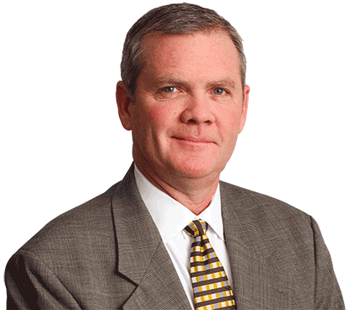
Achieving financial goals often requires a collaborative effort from executives in different roles.
Listen to an expert discuss how the CFO and chief operating officer (COO) work together to achieve company goals.
Financial Management Operating Units
Specific job titles and organizational structures vary according to a company's unique needs, but all insurers must perform certain core financial functions, as shown below.
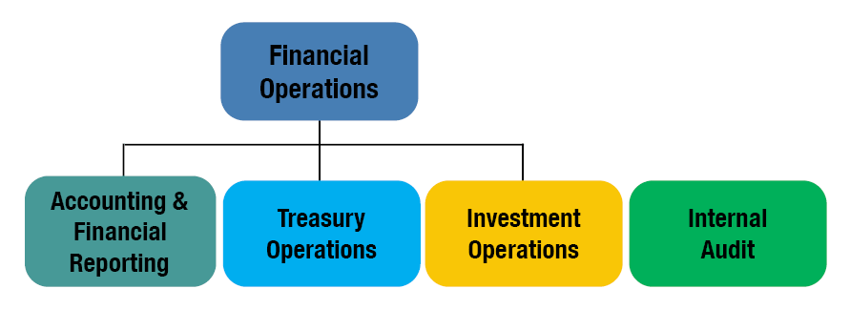

True or false?

An insurance company's investment committee directs the company's internal audit and control function.
- True
- False

Accounting and Financial Reporting
Learning Objectives
Describe the responsibilities of the accounting and financial reporting function.
Identify internal and external users of accounting information, and describe how financial accounting and management accounting meet their different needs.
Who directs the accounting and financial reporting function? The Controller.

My title at Forthright is Controller. Basically, I'm responsible for the timely and accurate collection and reporting of all of Forthright's financial data. What does that mean? Let's take a closer look at the accounting function.
The accounting function
- Records, tracks, and reports on financial transactions
- Coordinates the budget process and oversees expense analysis
- Prepares financial statements and reports for external users
- Gathers, records, analyzes, and distributes financial information to company managers
We produce many reports for many different parties. The type of report we create depends a lot on "who wants to know?"
Stakeholders from inside and outside the company use accounting information to make decisions. Who are these "customers" of the accounting department?

Of the following stakeholders, select the ones Forthright would consider to be internal users of its accounting information. Choose all that apply.
- Regulators
- Rating agencies
- Board of directors
- Policyowners
- Managers
- Investors
- Taxing authorities
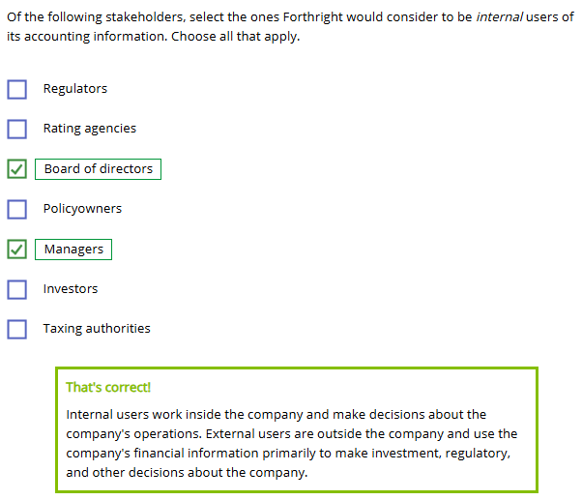
User Information Needs
Different parties have different needs for accounting information. Among other things, managers within the organization may use accounting information to
- Assess their departments' day-to-day operations
- Judge whether they are meeting their financial goals
- Plan for future needs
Now let's look at external users. Click or touch the right arrow to meet several users.

As a policyowner, I want to know that Forthright will have enough money to pay its bills. I want to be sure that it is financially stable. Will Forthright be able to pay my claim 25 years from now?
Financial Accounting and Management Accounting
Companies use two different types of accounting to meet the diverse needs of the users of their financial information:
- Financial accounting focuses on the needs of external users such as regulators, creditors, investors, rating agencies, and tax authorities.
- Management accounting focuses on the needs of internal users such as company managers.
Financial Accounting
Financial accounting starts with recording financial transactions. The end goal is the production of the company's financial statements.
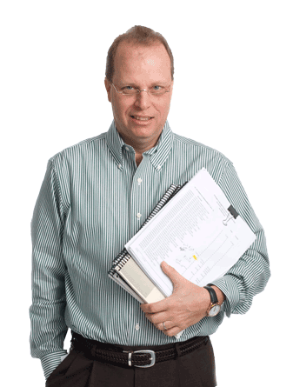

Wait!
You said that financial accounting is for external users—does this mean that internal managers don't use financial statements?
NO. I use financial statements to evaluate Forthright's performance. Financial statements show me whether we're meeting our goals and using our resources as best we can.
Financial statements summarize a company's financial transactions. These financial transactions can be product-specific items—premiums, commissions, investment transactions, marketing and product development expenses.
But there are also those items common to all businesses—payroll, disbursement of funds for operational expenses, like rent, keeping the lights on, and taxes.

Tax Accounting
Large insurers often have a separate function that handles tax reporting, which has its own set of reporting rules. In smaller companies, the accounting function typically is responsible for tax reporting.

For insurers, one unique aspect of tax accounting is premium taxes. Forthright pays premium taxes on the premiums paid to Forthright within a particular jurisdiction. Premium taxes are calculated as a percentage of these premiums.

That covers financial accounting. Let's contrast that with management accounting.

Since we've already discussed financial accounting, can you figure out which of the choices below describes management accounting?
- Helps external parties understand the company's financial situation and performance
- Helps company managers make the best use of internal resources
- Has a primary goal of producing financial statements for the company
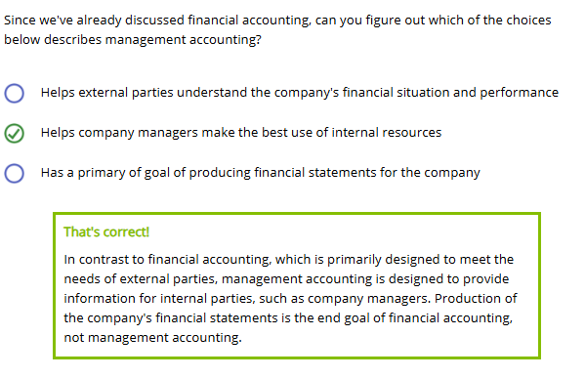

Let's try one more. True or false?
Management accounting is limited to analyzing past company performance.

- True
- False
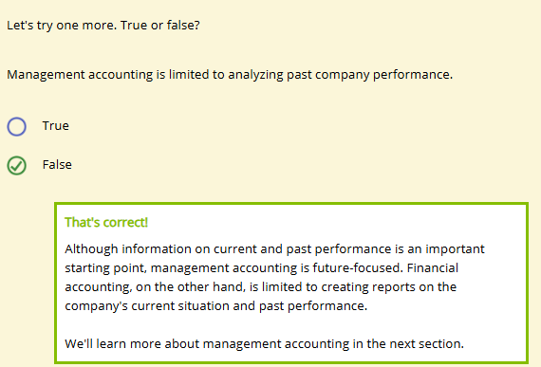
Management Accounting
Management accounting can focus on different parts of the business, such as
- Product lines or products
- Specific business functions
- Specific operating units

I use management accounting tools to
- Measure the profitability of products and services
- Analyze operating costs and manage expenses
- Budget resources to support goals
- Evaluate the efficiency of procedures and personnel

The person who manages accounting and financial reporting is generally the
- CFO
- Controller
- CEO
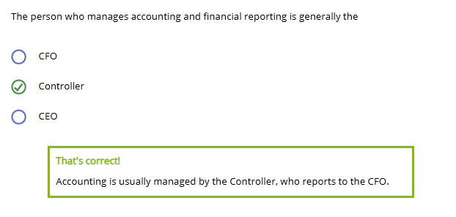
One type of tax paid by insurers is premium taxes. Most jurisdictions assess an insurer's premium taxes as a
- Percentage of premium income received
- Percentage of assets held
- Flat amount for each company
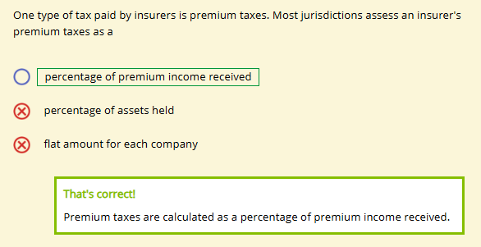
(Financial / Management) accounting reports on past performance and the current situation. (Financial / Management) accounting is designed to help managers make the best use of resources.
(Financial / Management) accounting reports on past performance and the current situation. (Financial / Management) accounting is designed to help managers make the best use of resources.
- Financial / Financial
- Financial / Management
- Management / Financial
- Management / Management

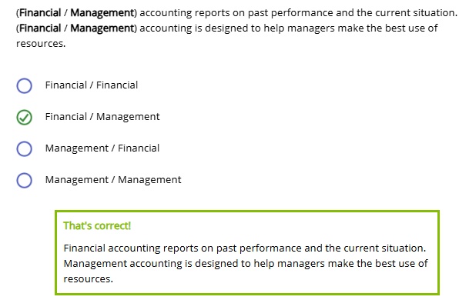

Budgets and Cost Accounting
Learning Objective
Describe how insurers use budgets and cost accounting as control tools.
Now let's talk about two of the most important tools of management accounting: budgets and cost accounting.
Budgets
A budget is a plan of action, expressed in monetary terms, that covers a specified time period.
Remember controls? A budget can be used as a steering control, a concurrent control, and a feedback control.
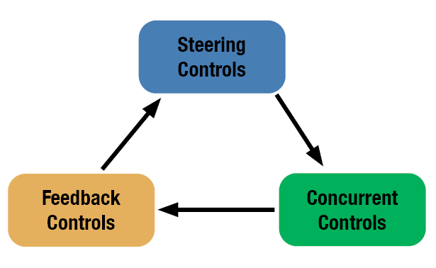
- Steering Controls: Managers develop revenue and expense projections for a specific period, usually one year. They use these projections to create a budget, which provides financial goals and guidance for activities during the year.
- Concurrent Controls: During the year, managers compare their actual results to budgeted projections, and then alter their activities accordingly. For example, if expenses are ahead of budget at mid-year, the company or a unit might cut back on certain expenses for the rest of the year.
- Feedback Controls: At year end, managers compare actual operating results to the budgeted numbers. Deviations between the two sets of numbers guide future activities and future budgets.
Budget Variances
At the end of the year, a difference between actual results and the budget is known as a budget variance. Managers probe budget variances to find what caused them. When they understand the causes, they can make adjustments for the future.

Let's look at an example.

I'm seeing some budget variances for this quarter. Take a look at this.
Operating Unit | Revenues | Expenses
Unit A | On target | Lower than budget
Unit B | Higher than budget | Lower than budget
Unit C | On target | On target
Which unit was the most successful?
- Unit A
- Unit B
- Unit C
- It depends
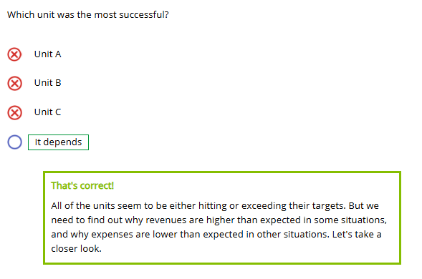

Suppose Barry, from Sales, comes in over budget on revenues. Should he be proud of this? Maybe, but there are some questions to ask. Like
…How did he achieve the high revenue?
…Did he sell products appropriately?
…Did external factors contribute?
Or consider the opposite. Should managers be happy if expenses are under budget? Maybe, but...
…Was quality or service sacrificed in cutting expenses?
…Could the money allocated to that unit have been better used elsewhere?
You can see how questions arise in either situation. A well-prepared budget allows a business to think about its goals and the best way to achieve them.
It's critical that budgets provide reliable estimates for revenues and expenses. Whether a variance is positive or negative is less important than the “Why?” You can't tell what effect a budget variance will have until you look at what is behind the numbers.
Cost Accounting
Cost accounting is a system for accumulating and categorizing expense data. The cost accounting information generated by the accounting area helps Forthright answer questions like these:
- What are our costs for a specific line of business?
- What will our future costs be for a specific product?
- What department, product, or line of business generated a specific cost?

Managers use the answers to these questions to manage their expenses and allocate resources.

In your company, you might hear terms like ''expense analysis,'' ''expense accounting,'' and “cost allocation” used to describe cost accounting functions.
An Ethical Dilemma
(Click or touch the arrows to the right.)

Hi Terrence, I want to explain a couple of things about this expense report. I want to make sure it goes through, because I really need this check.
If Terrence does not fulfill the responsibilities of his position, his job could be at risk.

Just because an amount is in the budget doesn't mean that this amount must be spent. All employees are responsible for controlling expenses and ensuring that resources are put to their best use.

Ultimately, the employee's success is tied to the company's success.

True or False?

A budget is both a steering control and a feedback control.
- True
- False
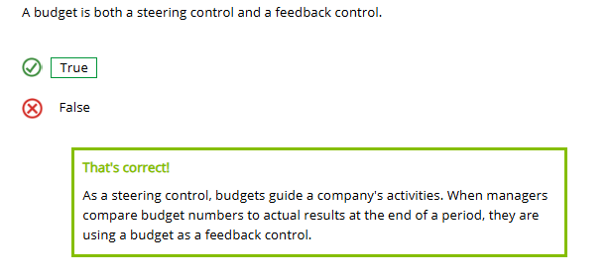
Managers should aim for their actual expenses to be below budget.
- True
- False
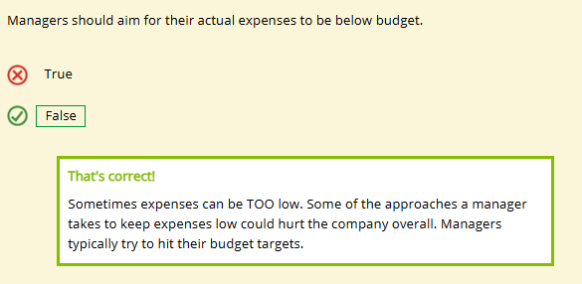

Treasury Operations and the Investment Management Function
Learning Objectives
Describe the treasury operations activities of cash management and liquidity management.
Describe the investment management function, including the role of the investment committee and the purpose of the investment policy.

I work in treasury operations, which is all about cash management: cash going in and cash going out. If it has to do with cash receipts, payments, or banking—that's Treasury Ops stuff. I report to Forthright's Treasurer. At Forthright, Treasury Operations reports up to the CFO—which is pretty typical.
Treasury Operations
- Controls cash flows in and out of the company
- Involves cash receipts, payments, and banking
- Is headed by the Treasurer, who reports to the CFO
Treasury Operations
Treasury operations manages cash and ensures that Forthright also earns the best possible return. Click or touch each Treasury function below to learn more.
Manages Liquidity
- Ensures that cash is available to meet Forthright's contractual obligations

Tracks Cash Flow
- Receives and disburses money
- Authorizes cash disbursements
- Records and allocates cash transactions

Banking
- Sets up bank accounts
- Reconciles bank statements
- Manages lockboxes for premium payments
- Earns a return on cash

Returns on cash?
You bet! Even cash is invested overnight or over the weekend. The rate of return may be small, but it's a lot of money. We can't afford to have it just sit there.

Treasury
- Invests excess cash in very short-term arrangements (overnight loans)
- Arranges for very short-term borrowing as needed (overnight borrowing)
Managing Investments
How insurers manage their investments affects not only policyowners and stockholders, but also other financial market participants.
All investments involve potential risks and returns. Financial managers identify risk and return characteristics and cash flow patterns and then build portfolios of investments that are likely to produce the desired results.
Let's look at the organization and operation of the investment department and how the investment staff adheres to certain guidelines when making decisions.
Investment Organization

Investment operations can be organized as a separate department—as it is at Forthright. Other options are that investment operations can be
- A subsidiary corporation
- A major division within a broader corporation, serving both the life insurance area and other business units
- Outsourced to another company
Some companies have a Chief Investment Officer (CIO), who reports directly to the CEO. At Forthright, the investment function reports to the CFO. Whatever the organizational scheme, the direction for the investment function starts at the top—with the board of directors.
This figure illustrates the interplay between the investment committee and a company's investment operations.
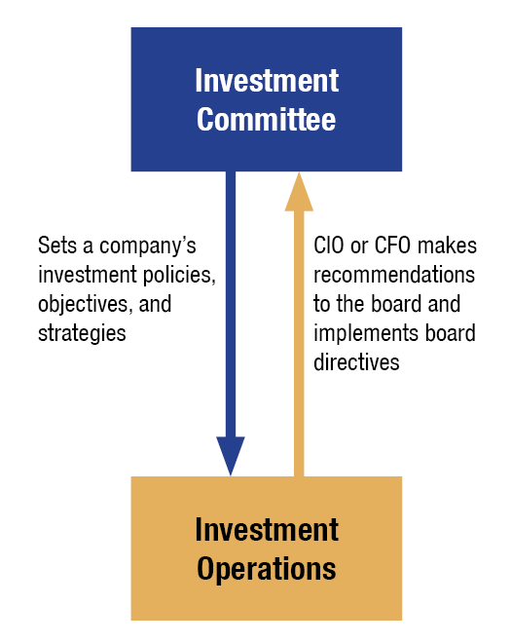
Investment Policy
An investment policy is a set of rules and guidelines that specifies
- Long-term investment objectives for the company
- Acceptable investment strategies for achieving investment goals
- Acceptable types of investments
- Controls and risk management procedures (like policies defining who is authorized to make what trades)
- Limits on specific investments, prohibited assets, and trading activities
- Consistent standards for measuring investment performance
The CIO or CFO makes recommendations to the board regarding investment policy. When investment decisions are made, he makes sure they are in line with investment policy and regulatory requirements. He also communicates to the accounting and actuarial areas the current and expected rates of return on the company's investments.
So what does everyone else do? Click or touch in the box below to see.

Other Jobs in Investment Operations
Other jobs in an insurance company's investment department include
- Investment analysts, who conduct research into specific investment opportunities
- Economists, who forecast and track economic trends
- Portfolio managers, who coordinate investment strategies for specific investment accounts
- Traders, who buy and sell securities such as bonds and stocks


The Treasury Operations area is responsible for (choose all that apply):
- Lending cash overnight
- Borrowing money for the long term
- Borrowing cash overnight
- Lending money for the long term
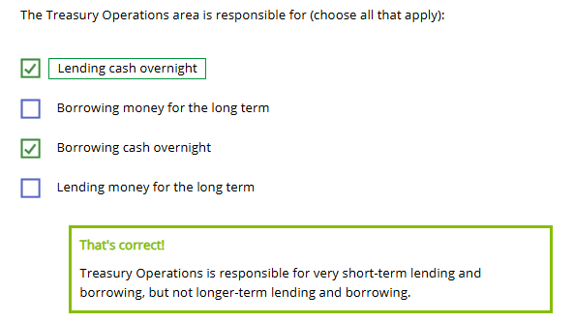
Of the following activities, select the ones that are generally the responsibility of the investment committee of the board of directors. Choose all that apply.
- Setting long-term investment objectives for the company
- Conducting research into specific investment opportunities
- Buying and selling securities
- Placing limits on the types of investments that the company may hold
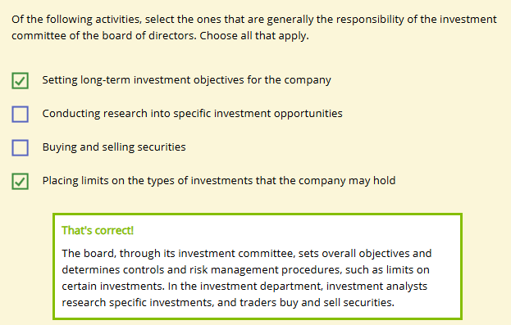

Securities in the Insurer's General and Separate Accounts
Learning Objectives
Describe the different types of securities, and distinguish between debt securities and equity securities.
Distinguish between an insurer's general account and separate account portfolios.

Insurers invest primarily in financial securities such as high-quality bonds, commercial mortgages, and corporate stock. A financial security represents either an investor's
- Ownership interest in a business or property—equity security
OR
- Loan of funds to a debt issuer—debt security
Help! What is a mortgage? What is a bond? What is corporate stock?
Click or touch each heading below to find out.
Mortgage
A mortgage is
- A debt security
- A long-term loan secured by a pledge of specified property
- Used for commercial property (office buildings, shopping centers) or residential properties (houses, condominiums)

Bond
A bond is
- A debt security
- A form of financing for businesses and governments
- A loan:
- Issuer = Borrower
- Investor = Lender

The bond issuer generally pays a predetermined amount of interest at regular intervals—usually, semiannually or annually—and then pays back the face amount of the bond on a set date in the future.

Corporate Stock
Corporate stock is
- An equity security
- An ownership interest in the issuing company

The investor hopes to make money from
- Stockholder dividends—payments to the stockholders of a portion of the corporation's yearly earnings, and/or
- Capital gains—returns earned by selling stock for more than it was purchased for.

General and Separate Accounts
Forthright Financial organizes its invested assets into two major types of portfolios—that is, collections of assets with a given objective. Click or touch each heading below to learn more.
General Account
A general account is an asset portfolio
- In which the insurer bears the investment risk
- That supports guaranteed products

Separate Accounts
Separate accounts are asset portfolios
- In which the customer bears the investment risk
- That support variable products


Based on what you have seen so far, what would you predict is the primary type of security in an insurer's general account?
- Government and corporate bonds
- Commercial mortgages
- Stocks
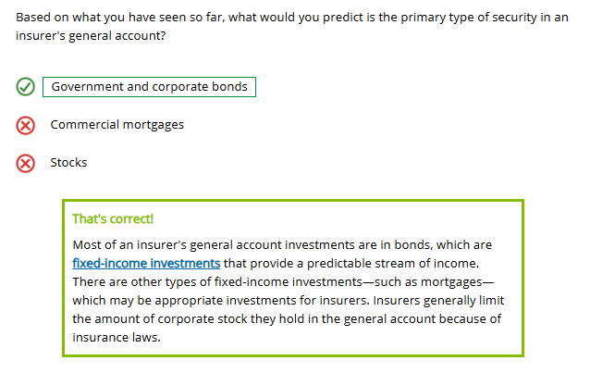

Insurers are more likely to hold their stock investments in a separate account. Customers, rather than the insurer, generally accept the investment risk (and the returns!) of products supported by a separate account.
Based on their own investment goals and risk tolerance, customers select from investment subaccounts offered by the insurer. A subaccount is similar to a mutual fund, usually investing in a certain type of investment.
Here are some examples of different subaccount types. Maybe you have seen some of them in your 401(k) or annuity prospectus?
- Equity index fund
- Mid-cap stock fund
- Energy fund
- High-yield bond fund
- Asia Pacific fund

True or False?

Debt securities represent the investor's loan of funds to the debt issuer in return for the promised repayment of principal and payment of interest.
- True
- False
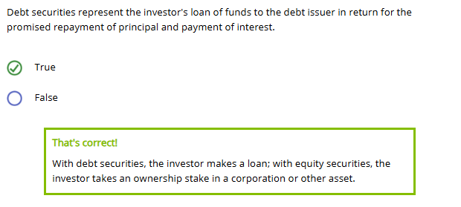
One example of an equity security is
- A bank deposit
- A bond
- A mortgage loan
- Corporate stock
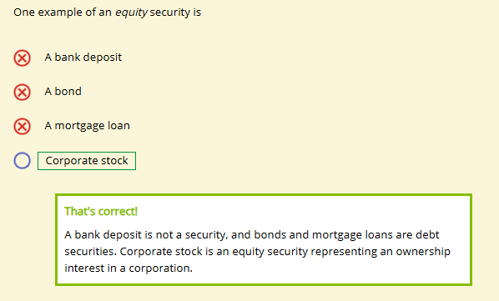
Most insurers have two major types of portfolios: the general account and one or more separate accounts.

True or False?

The general account contains assets that support liabilities associated with an insurer's variable products, such as variable life insurance policies and variable annuities.
- True
- False
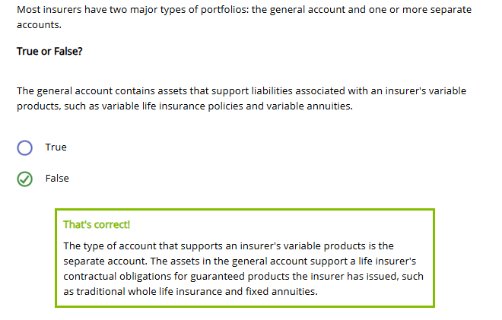
The investment risk associated with a separate account is assumed by the customers who purchase variable products rather than by the insurer.
- True
- False
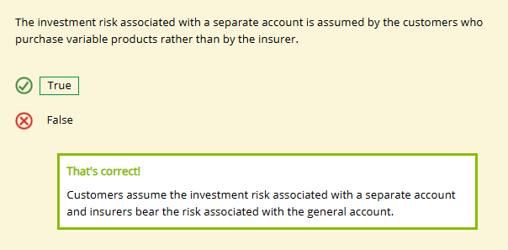
Insurers hold a greater percentage of corporate stock in their general account than in their separate accounts.

Insurers hold a greater percentage of corporate stock in their general account than in their separate accounts.
- True
- False
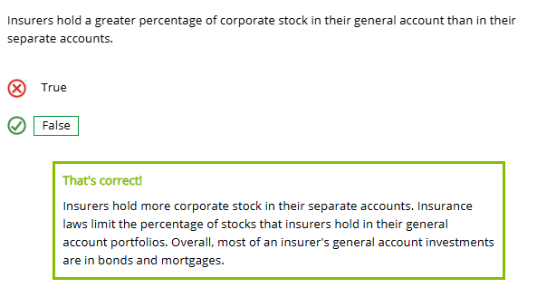

Audit and Internal Control
Learning Objective
Explain the importance of the audit and internal control function, and describe other players in an insurer's financial operations.
Now let's discuss the audit function. Audits provide objective evaluations of the company's financial and operational business activities, including its corporate governance. Internal auditors evaluate operations and recommend ways to improve the overall corporate structure and efficiency.
The internal audit and control function is essential to financial and operational risk management. In this lesson, we focus on financial control.
The Audit Function
(click or touch the arrows to the right)

At Forthright, the audit function reports directly to the audit/risk committee of Forthright's board of directors. Can you think of a reason why audit reports directly to the board?

The audit function must operate independently from other financial functions within the company, so that auditors are independent and unbiased.

Internal Audit
An important control tool for managing risk is the internal audit—a systematic examination and evaluation of a company's records, processes, and controls by company employees.
An internal audit can focus on any area within the company—and different auditors have different specialties. Auditors examine records, processes, and controls in underwriting, claims, or customer service.
Internal Financial Audit
One specialized type of internal audit is the internal financial audit. The auditor is looking for the answers to these questions:
- Are our financial records fair and accurate?
- Are our control procedures adequate? Are we following them?
- Are our assets safeguarded?
- Are we meeting our compliance obligations?
Auditors communicate audit results to the audit/risk committee and the appropriate management groups. If they find problems, they recommend improvements, and then follow up.
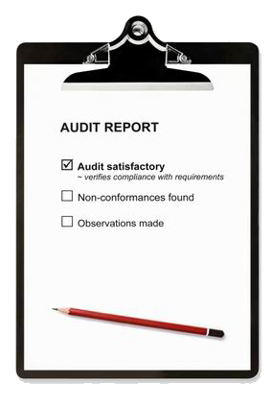
External Audits
The audit department also works with external auditors and regulators to provide them with the information they need about the company.

An external audit is conducted by an independent party.

We'll learn more about external audits in the next lesson.
Other Players in Financial Operations

An insurer's financial activities require close cooperation between many functional areas to provide employees with the information they need every day to do their jobs.
Let's look at a few of these.
Actuarial
In addition to determining the financial design of new products, the actuarial department performs a number of other financial management activities, including
- Projecting cash flows, including premium payments, investment income, and benefit payments
- Coordinating income from investments with benefit obligations
- Setting policy reserve liabilities
- Financial reporting activities

These functions are so closely intertwined that the actuarial area reports directly to the CFO in some companies.
Information Technology (IT)
Most of the processes for recording financial transactions, for financial reporting, and for managing investments are automated. The IT department also plays an essential role in maintaining the quality of the information provided to decision makers and improving operational efficiency.

Data quality is critical to the financial management function.
Risk Management
Forthright's financial managers work closely with the Chief Risk Officer.

To reduce the company's risk exposure, they
- Define strategic, operational, financial, or compliance-related risks
- Determine appropriate financial risk tolerances
- Measure and monitor financial risk
- Identify risks and ways to mitigate risks financially

One control tool an insurer uses is a systematic examination and evaluation of its records, processes, and controls by company employees. This control tool is an
- ⭘ Internal audit
- ⭘ Internal budget
- ⭘ External audit
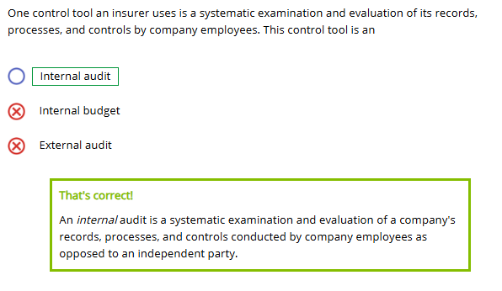
The audit function in an insurance company typically reports to the
- ⭘ CEO
- ⭘ CFO
- ⭘ Audit/risk committee of the board of directors
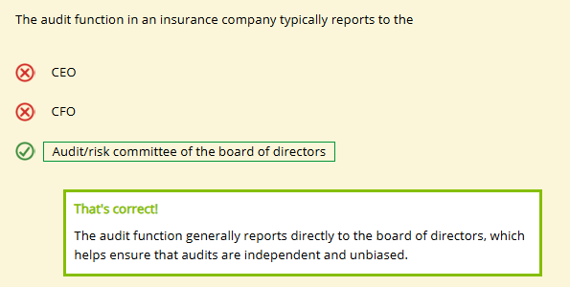
Calculating policy reserve liabilities and projecting cash flows are activities completed by which of the following departments?
- ⭘ Risk management
- ⭘ IT
- ⭘ Actuarial
